Test Case: tc006_SPX_Dev5_Crear_Requisicion_Spot_Tipo_Cobro_Proyect_Urgent
Step 1 - Enter username and password and click to button Enter: Credentials Entered
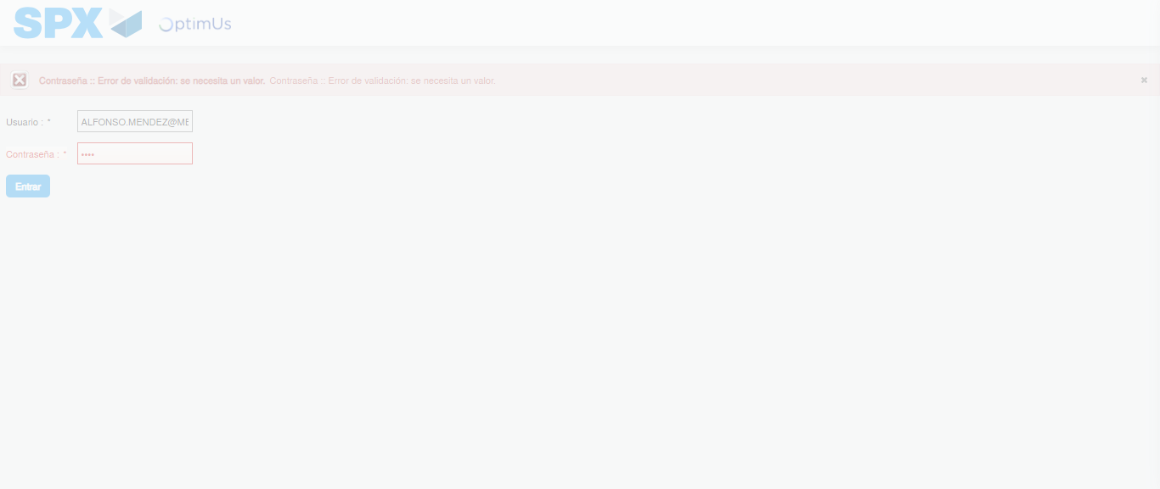Image file-name: QC_Testing-tc006_SPX_Dev5_Crear_Requisicion_Spot_Tipo_Cobro_Proyect_Urgent-1783361752497

Step 2 - Select to UEN and Access to Spot Buy Requisitions : UEN Correctly selected and Correct access
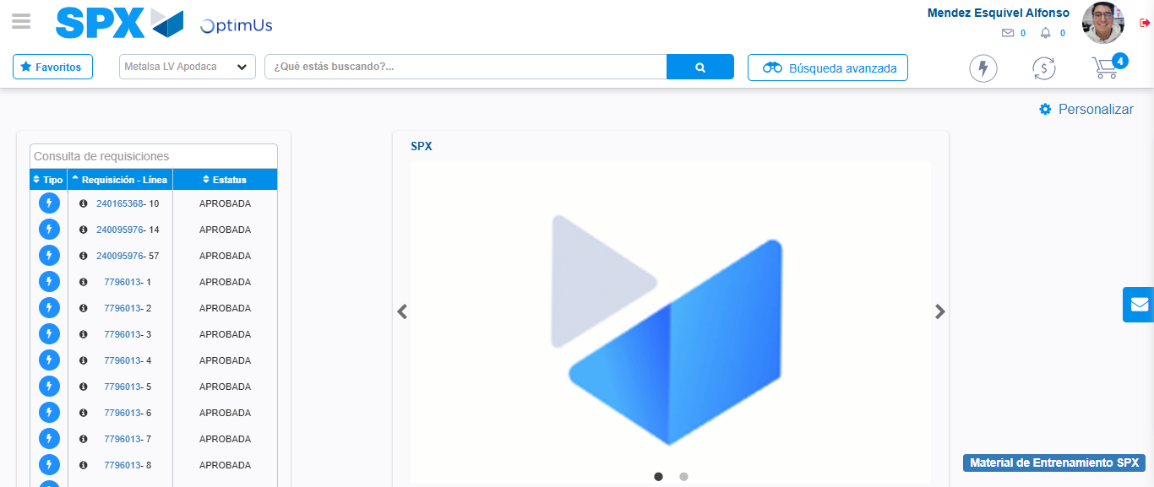Image file-name: QC_Testing-tc006_SPX_Dev5_Crear_Requisicion_Spot_Tipo_Cobro_Proyect_Urgent-1783361777762

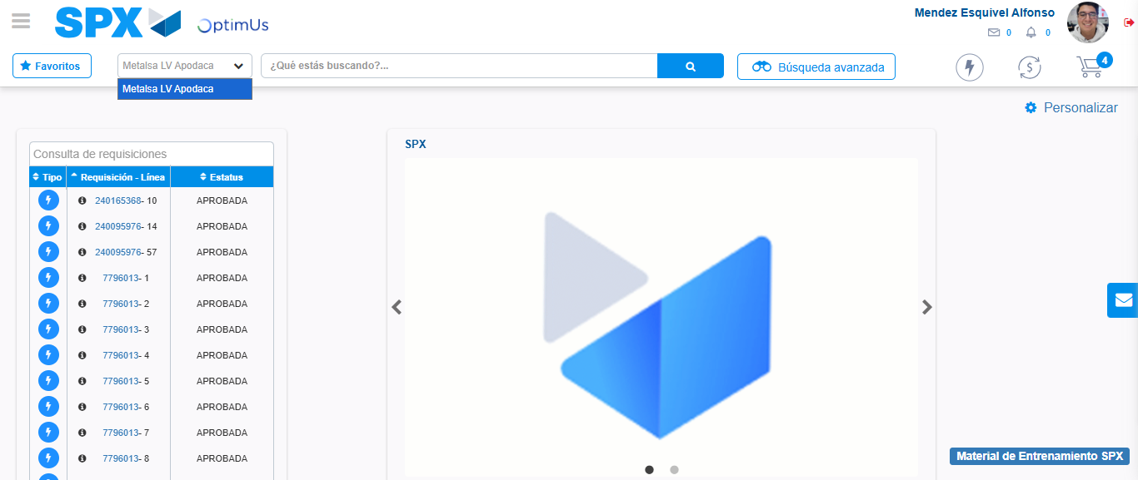Image file-name: QC_Testing-tc006_SPX_Dev5_Crear_Requisicion_Spot_Tipo_Cobro_Proyect_Urgent-1783361780521

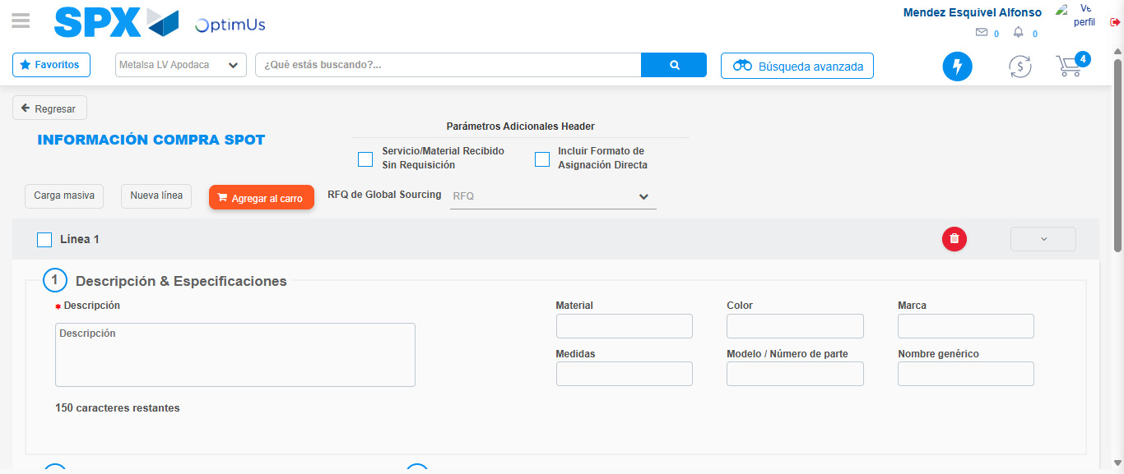Image file-name: QC_Testing-tc006_SPX_Dev5_Crear_Requisicion_Spot_Tipo_Cobro_Proyect_Urgent-1783361805510

Step 3 - Data Capture Spot Buy Requisition: Data captured correctly
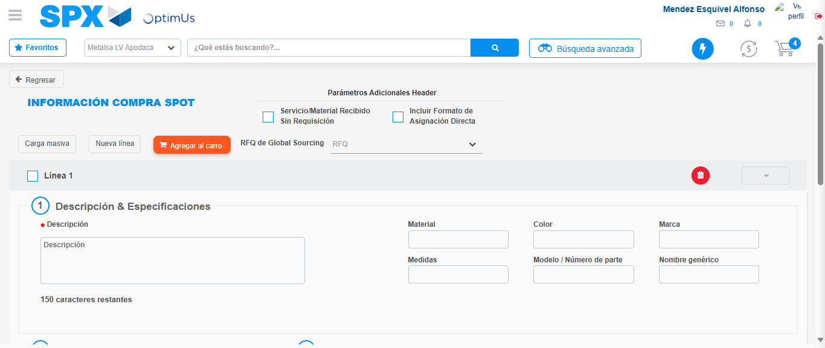Image file-name: QC_Testing-tc006_SPX_Dev5_Crear_Requisicion_Spot_Tipo_Cobro_Proyect_Urgent-1783361805843

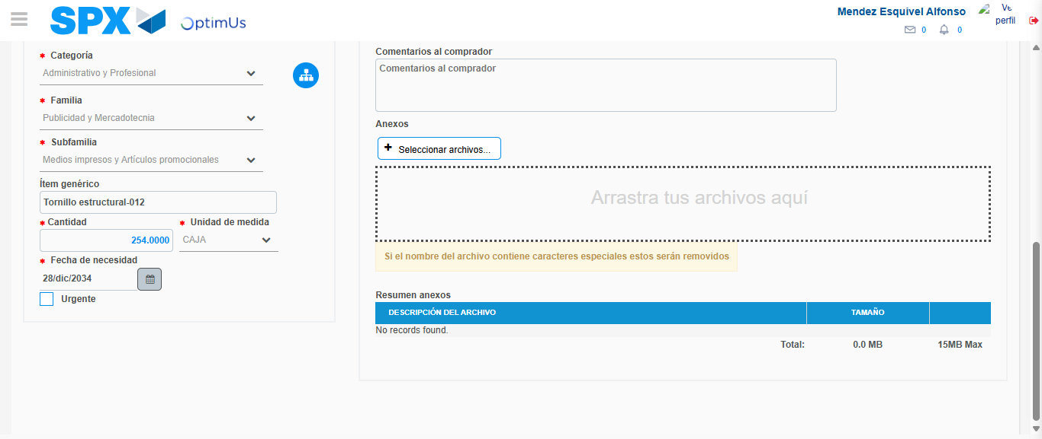Image file-name: QC_Testing-tc006_SPX_Dev5_Crear_Requisicion_Spot_Tipo_Cobro_Proyect_Urgent-1783361817984

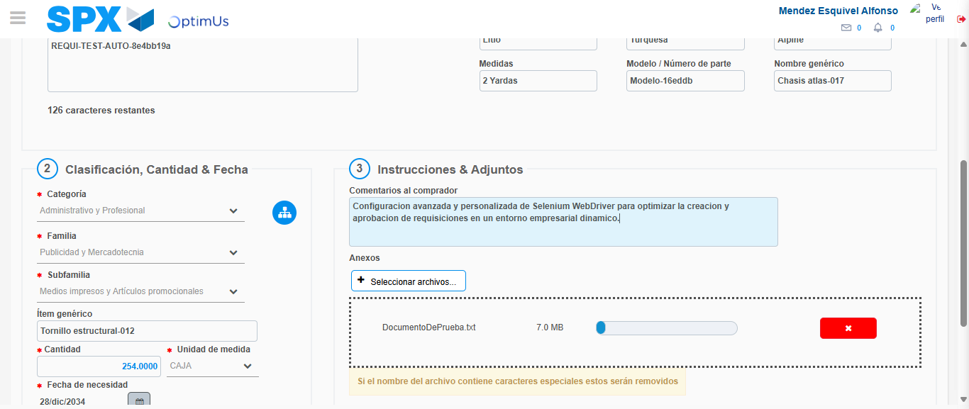Image file-name: QC_Testing-tc006_SPX_Dev5_Crear_Requisicion_Spot_Tipo_Cobro_Proyect_Urgent-1783361818952

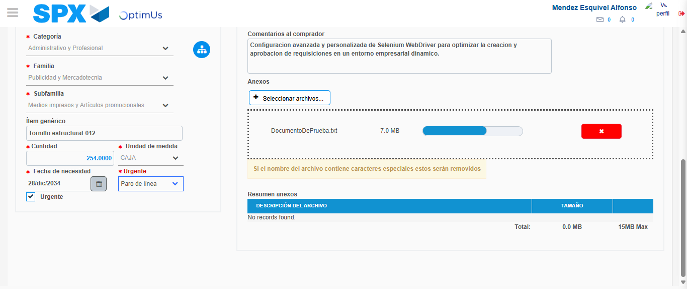Image file-name: QC_Testing-tc006_SPX_Dev5_Crear_Requisicion_Spot_Tipo_Cobro_Proyect_Urgent-1783361822910

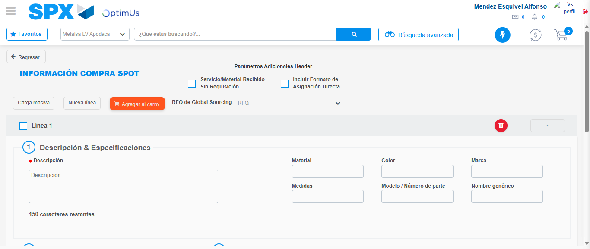Image file-name: QC_Testing-tc006_SPX_Dev5_Crear_Requisicion_Spot_Tipo_Cobro_Proyect_Urgent-1783361824472

Step 7 - Return to Main Page SPX : Return to Main Page SPX
Image file-name: QC_Testing-tc006_SPX_Dev5_Crear_Requisicion_Spot_Tipo_Cobro_Proyect_Urgent-1783361777762

Image file-name: QC_Testing-tc006_SPX_Dev5_Crear_Requisicion_Spot_Tipo_Cobro_Proyect_Urgent-1783361780521

Image file-name: QC_Testing-tc006_SPX_Dev5_Crear_Requisicion_Spot_Tipo_Cobro_Proyect_Urgent-1783361805510

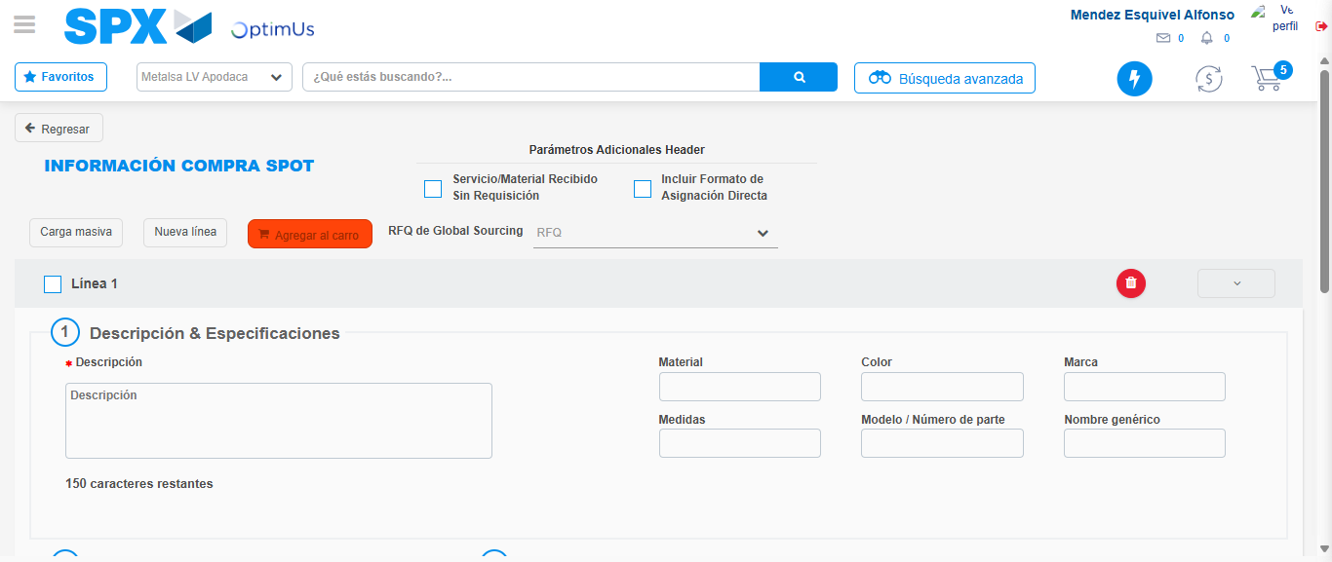Image file-name: QC_Testing-tc006_SPX_Dev5_Crear_Requisicion_Spot_Tipo_Cobro_Proyect_Urgent-1783361826739

Image file-name: QC_Testing-tc006_SPX_Dev5_Crear_Requisicion_Spot_Tipo_Cobro_Proyect_Urgent-1783361826972

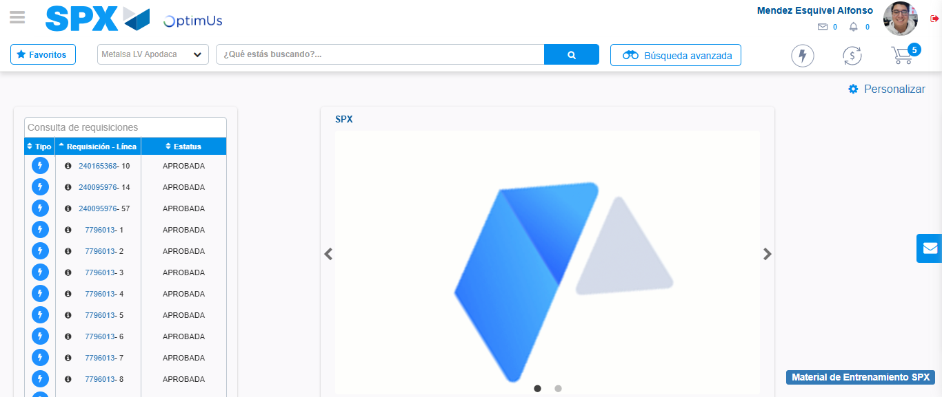Image file-name: QC_Testing-tc006_SPX_Dev5_Crear_Requisicion_Spot_Tipo_Cobro_Proyect_Urgent-1783361847953

Step 8 - Log Out : Log Out SPX
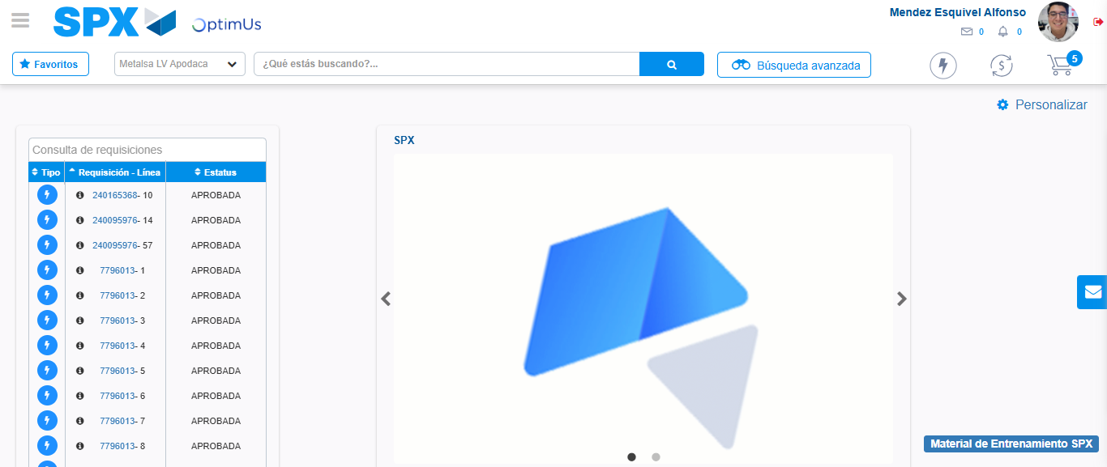Image file-name: QC_Testing-tc006_SPX_Dev5_Crear_Requisicion_Spot_Tipo_Cobro_Proyect_Urgent-1783361848246

